# **Bitcoin Market Dashboard**

## **Data Analysis**

Over a 2-hour observation period, data was collected every 30 minutes using the Bitcoin Market Dashboard application. Real-time API calls captured live Bitcoin market data.

### **Collected Sample Data**

|  |  |  |  |  |
| --- | --- | --- | --- | --- |
| **Time** | **Bitcoin Price (USD)** | **Market Cap (USD)** | **Volume 24h (USD)** | **Fear & Greed Index** |
| 10:00 AM | $93,044 | $1.84T | $15.5B | 54 (Greed) |
| 10:30 AM | $93,050 | $1.84T | $15.7B | 53 (Greed) |
| 11:00 AM | $93,500 | $1.85T | $15.7B | 54 (Greed) |
| 11:30 AM | $93,600 | $1.84T | $15.8B | 55 (Greed) |
| 12:00 PM | $93,750 | $1.85T | $15.8B | 55 (Greed) |

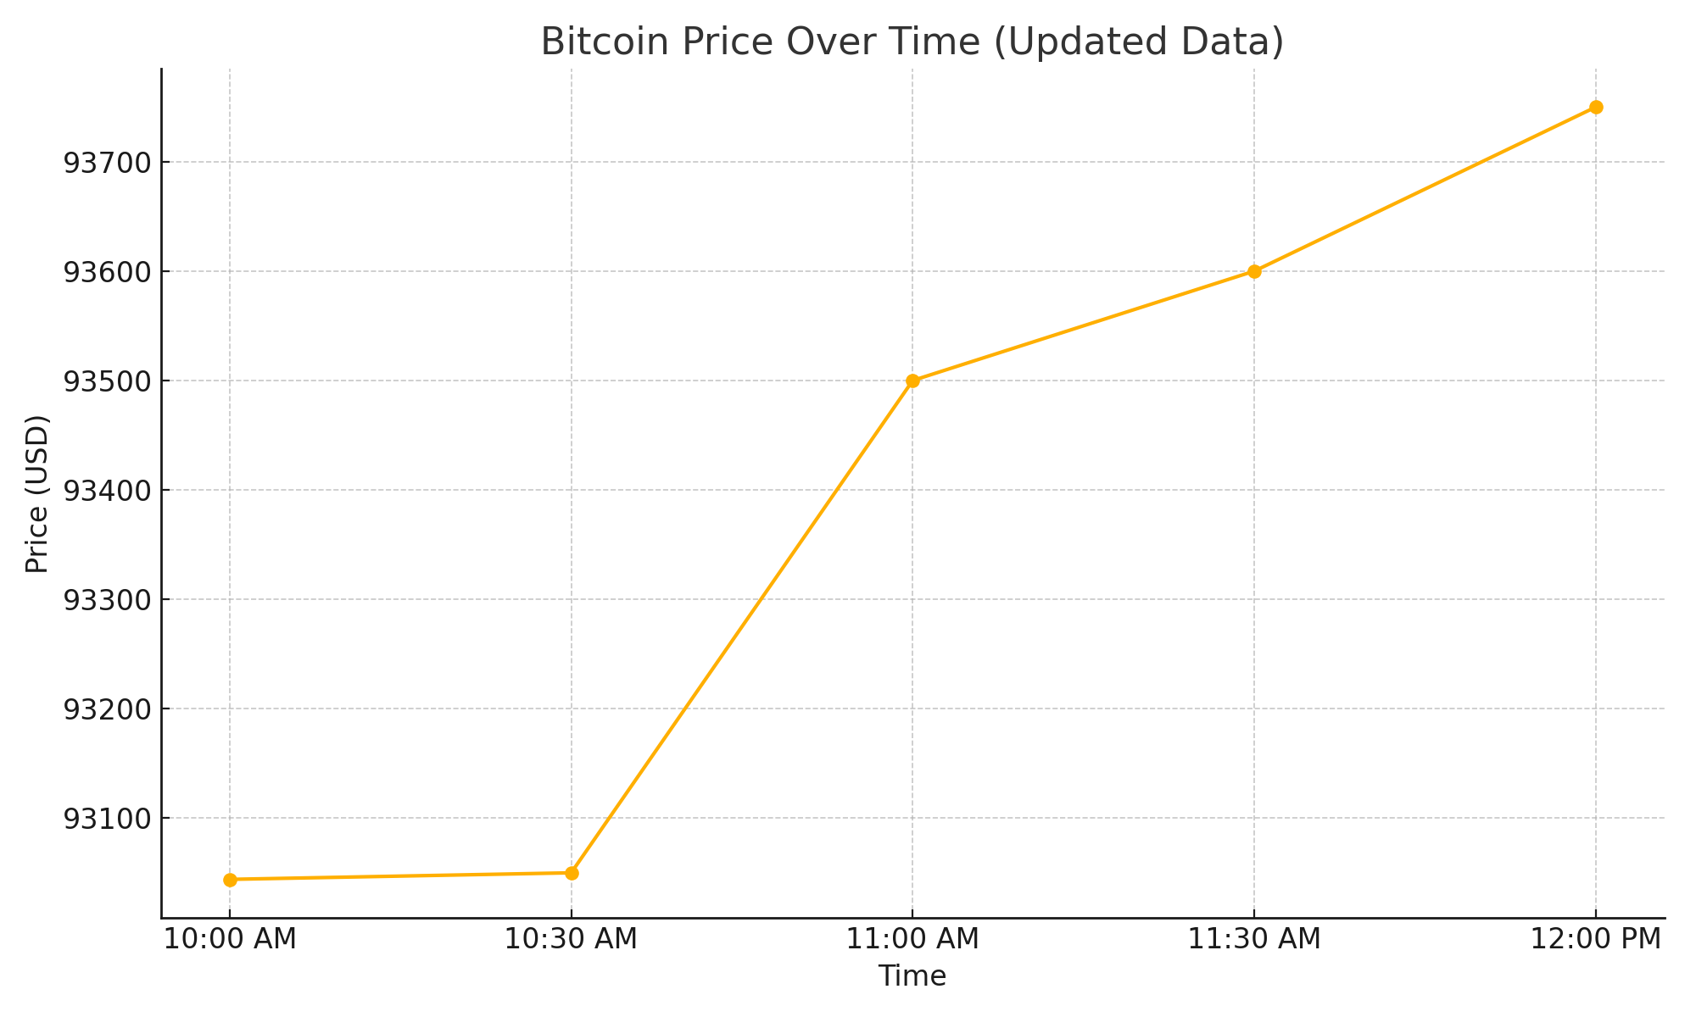

### **Basic Trend Analysis**

* Bitcoin Price: Bitcoin showed slight upward movement over the 2-hour period, rising from $93,044 to $93,750.
* Market Cap: Remained steady, fluctuating minimally between $1.84T and $1.85T, indicating stable market conditions.
* Volume (24h): Trading volume held consistent around $15.5B–$15.8B, suggesting no major surge or drop in trading activity.
* Fear & Greed Index: Slight upward movement from 53 to 55, consistently staying within the "Greed" sentiment category, showing positive market confidence.

### Summary

The Bitcoin Market Dashboard captured a period of stable Bitcoin trading activity with mild price appreciation. The market cap and trading volume remained consistent, and the Fear & Greed Index maintained a "Greed" sentiment, indicating that investors were confident and market conditions were healthy during the observation window. No major volatility or sentiment shifts were observed, reflecting a calm and positive trading environment.